**Database management systems**

# **Labsheet – 8**

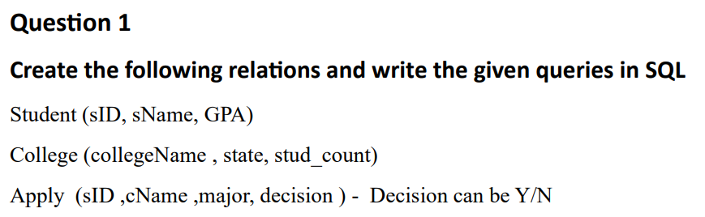

CREATE TABLE Students(SID INTEGER PRIMARY KEY,

                     Sname VARCHAR(25),

                     GPA NUMERIC(4, 2));

CREATE TABLE College(Collegename VARCHAR(25) PRIMARY KEY,

                     State VARCHAR(25),

                     stud_count INTEGER);

CREATE TABLE Apply(SID INTEGER,

                   Cname VARCHAR(25),

                   major VARCHAR(25),

                   Decision CHAR(1),

                   PRIMARY KEY(SID, Cname),

                   FOREIGN KEY (SID) REFERENCES Students(SID),

                   FOREIGN KEY (Cname) REFERENCES College(Collegename));

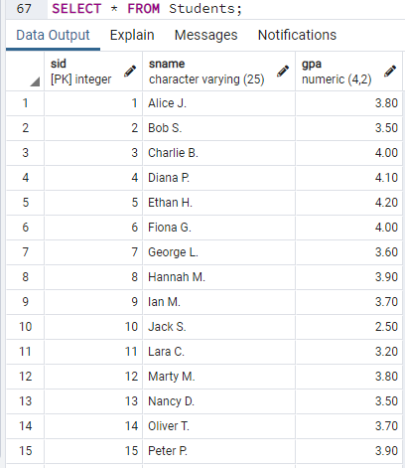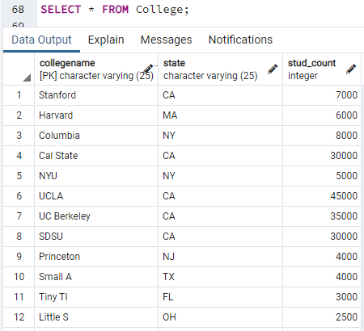  
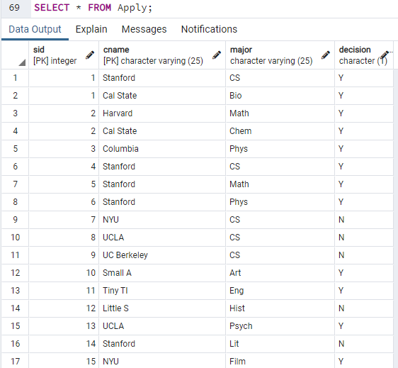

  
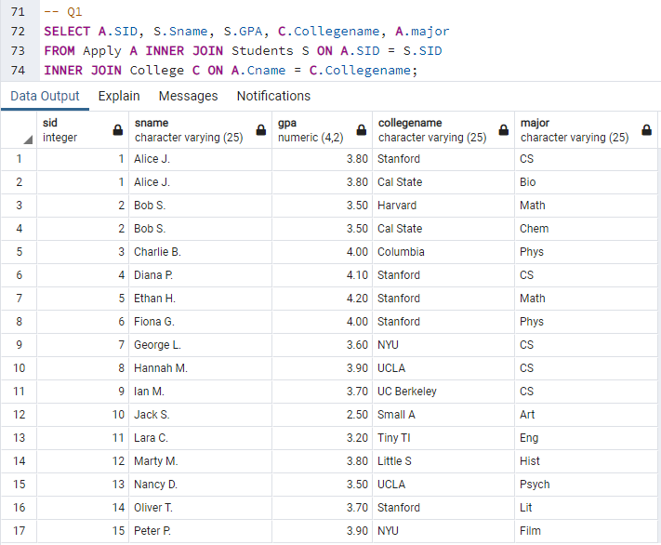

  
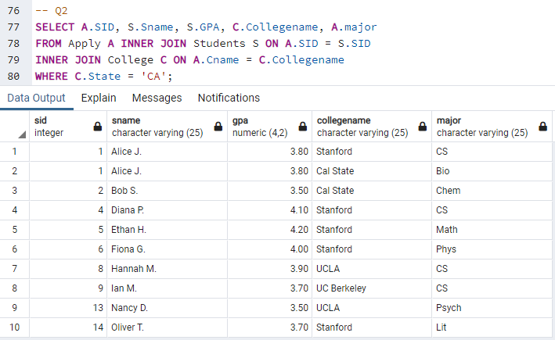

  
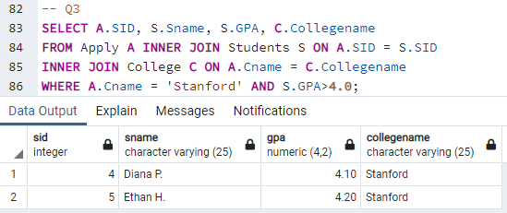

  
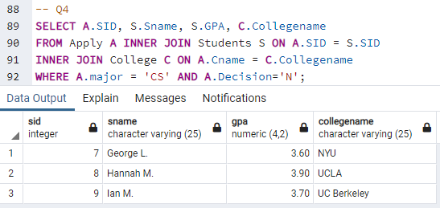

  
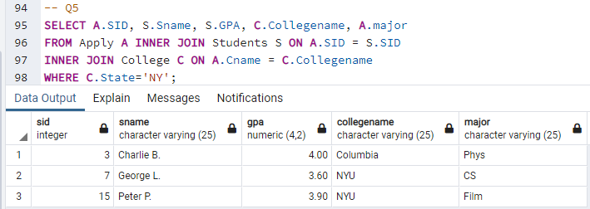

  
  
-- Q6: Find details of students who have not applied to any college.

SELECT S.SID, S.Sname, S.GPA

FROM Students S

WHERE S.SID NOT IN (SELECT A.SID FROM Apply A);

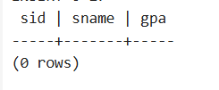



-- Q7: Find college where no student has applied.

SELECT C.Collegename

FROM College C

WHERE C.Collegename NOT IN (SELECT A.Cname FROM Apply A);

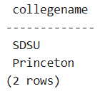



-- Q8: Find SID who have only one application.

SELECT A.SID

FROM Apply A

GROUP BY A.SID

HAVING COUNT(A.SID) = 1;

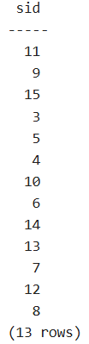



Find name and GPA of applicants who apply to any college where student count is not more than 5000.

SELECT S.Sname, S.GPA

FROM Apply A

INNER JOIN Students S ON A.SID = S.SID

INNER JOIN College C ON A.Cname = C.Collegename

WHERE C.stud_count <= 5000;

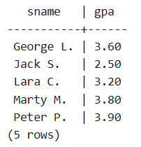



-- Q10: Find various majors student applied in at colleges in state California.

SELECT DISTINCT A.major

FROM Apply A

INNER JOIN College C ON A.Cname = C.Collegename

WHERE C.state = 'CA';

